1.

Program:

<!DOCTYPE html>

<html>

<head>

    <title>Student Information</title>

</head>

<body>

    <center><h1>STUDENT INFORMATION</h1>

    <form action="#">

        <table>

            <tr>

                <td class="name">Register No:</td>

                <td><input type="text"></td>

            </tr>

            <tr>

                <td>Student Name:</td>

                <td><input type="text"></td>

            </tr>

            <tr>

                <td>D.O.B:</td>

                <td><input type="date"></td>

            </tr>

            <tr>

                <td>Age:</td>

                <td><input type="number"></td>

            </tr>

            <tr>

                <td>Courses:</td>

                <td><select>

            <option value="1">Select the course</option>

            <option value="B.C.A">B.C.A</option>

            <option value="B.Sc CS">B.Sc CS</option>

            <option value="B.Sc IT">B.Sc IT</option>

            <option value="B.Com">B.com</option>

        </select></td></tr>

            <tr>

            <td><button type="button">Submit</button></td>

            <td><button type="button">Cancel</button></td>

        </tr>

        </table>

    </form></center>

</body>

</html>

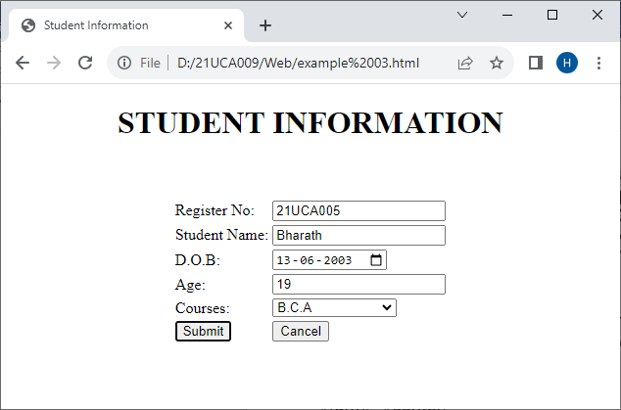

2.

Program:

<html>

<head>

    <title>BCA Timetable - III Year</title>

</head>

<body>

<table border="1" cellpadding="1" cellspacing="0">

    <tr height="40">

        <th>Dayorder</th>

        <th width="120">I Period</th>

        <th width="120">II Period</th>

        <th width="120">III Period</th>

        <th width="120">IV Period</th>

        <th width="120">V Period</th>

    </tr>

    <tr height="40">

        <td align="center">I</td>

        <td>SE</td>

        <td>CS</td>

        <td>WT</td>

        <td>CN</td>

        <td>CS</td>

    </tr>

    <tr height="40">

        <td align="center">II</td>

        <td>CN</td>

        <td>SE</td>

        <td colspan="2" align="center">Networking Lab</td><td>WT</td>

    </tr>

    <tr height="40">

        <td align="center">III</td>

        <td>CN</td>

        <td>CS</td>

        <td colspan="2" align="center">WT Lab</td>

        <td>WT</td>

    </tr>

    <tr height="40">

        <td align="center">IV</td>

        <td>SE</td>

        <td>WT</td>

        <td>CN</td>

        <td>CS</td>

        <td>SE</td>

    </tr>

    <tr height="40">

        <td align="center">V</td>

        <td>SE</td>

        <td>CN</td>

        <td colspan="2" align="center">Networking Lab</td>

        <td>WT</td>

    </tr>

    <tr height="40">

        <td align="center">VI</td>

        <td colspan="2" align="center">WT Lab</td>

        <td>CN</td>

        <td>CS</td><td>WT</td>

    </tr>

</table>

</body>

</html

Output:

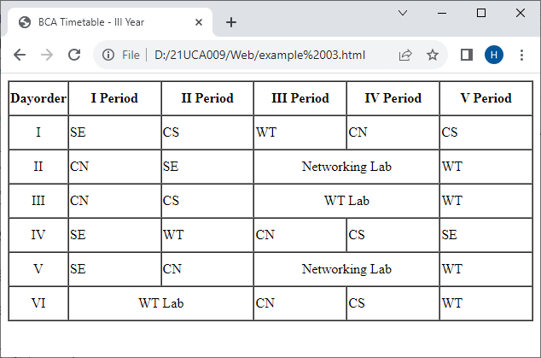

3.

Index.html

Program:

<!DOCTYPE html>

<html lang="en">

<head>

    <title>SRMVCAS</title>

    <frameset cols="25%,*">

    <frame src="title.html" name="title”>

    <frame src="home.html" name="content">

    </frameset>

</head>

<body>

</body>

</html>

Home.html

Program:

<!DOCTYPE html>

<html>

<head>

    <title>SRKV</title>

</head>

<body>

    <p> Ramakrishna Mission Vidyalaya, Coimbatore, is a major

        educational centre of the well-known Ramakrishna Mission. It is 19 km from

        the Coimbatore City on the highway to Ootacamund,and situated in a serene

        environment spread over about 300 acres. The Institution was founded by Sri

        T.S. Avinashilingam in 1930 with an investment of just Rs. 5.75 and with one

        harijan boy on its roll. Ramakrishna Mission Vidyalaya, Coimbatore, a branch

        centre of the Ramakrishna Mission, P.O. Belur Math, Dist. Howrah, West

        Bengal - 711 202, India.  </p>

</body>

</html>

History.html

Program:

<!DOCTYPE html>

<html lang="en">

<head>

    <title>History</title>

</head>

<body>

    <P>The college was started in the year 1964 with blessings of Srimat Swami Madhavanandaji Maharaj and has completed 43 years of useful and meaningful service to the student community and society.</P>

</body>

</html>

Imagecode.html

Program:

<!DOCTYPE html>

<html>

<head><title>Images</title></head>

<body>

<h2>The Picture Element</h2>

<picture>

    <source media="(min-width: 650px)" srcset="img_pink_flowers.jpg"> <source media="(min-width: 465px)" srcset="img_white_flower.jpg">

    <img src="img_orange_flowers.jpg" alt="Flowers" style="width:auto;">

</picture>

</body>

</html>

AudioVideo.html

Program:

<!DOCTYPE html>

<html>

<head>

    <title>Multimedia Controls</title>

</head>

<body>

    <h1>Multimedia - Video Control</h1>

    <video width="500" height="350" controls>

        <source src="GIT.mp4" type="video/mp4">

            Your browser does not support the video tag.

    </video><br><br>

    <h1>Multimedia - Audio Control</h1>

    <audio controls>

        <source src="MusicSpace.mp3" type="audio/mpeg">

            Your browser does not support the audio element.

    </audio>

</body>

</html>

Output:

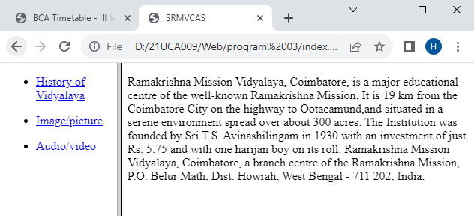

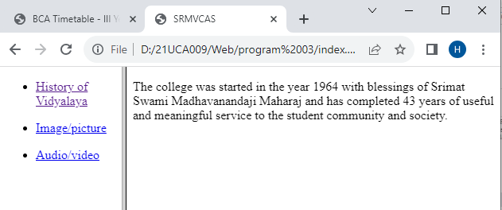

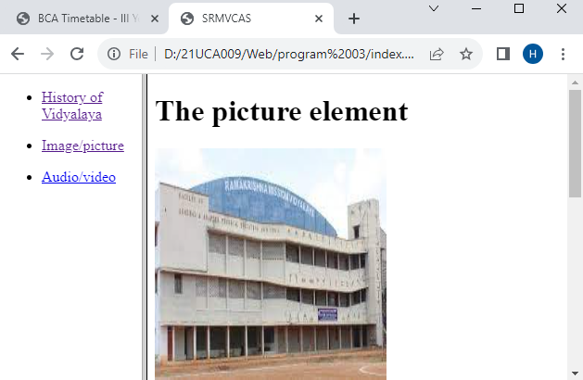

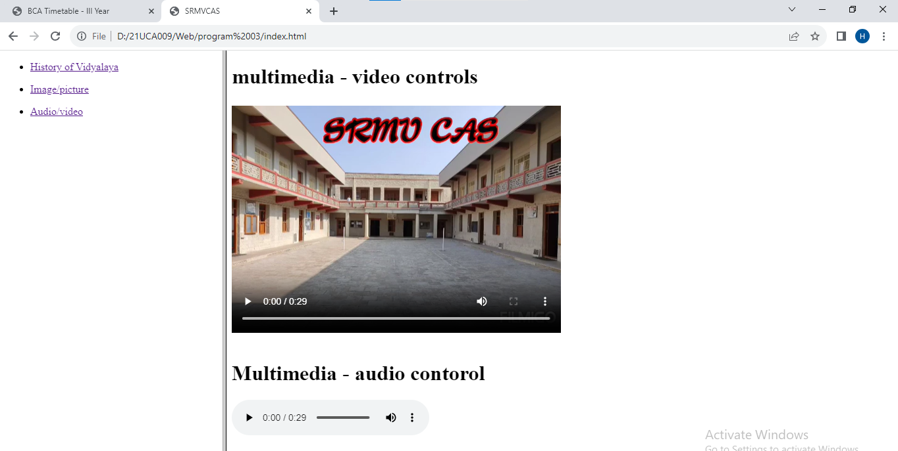

**10.Students Detail – Save Mode.**

<?php

ob_start();

session_start();

$conn=mysqli_connect('localhost','root','') or die("cannot connect mysqli");

mysqli_select_db($conn,"bca")or die("cannot select bca database");

if(isset($_REQUEST["mode"])=="save")

{

    mysqli_query($conn,"insert into tblstudent values('".$_POST["txt_regno"]."','".$_POST["txt_sname"]."','".$_REQUEST["cmb_dept"]."','".$_POST["cmb_year"]."','".$_POST["cmb_sem"]."')");

    if(mysqli_affected_rows($conn)){

        $_SESSION['msg']="Saved successfully";

    }

    header("location:student1.php");

    die();

}

    if(isset($_REQUEST["mode"])==""){

?>

<!DOCTYPE html>

<html lang="en">

<head>

    <title>Student Details</title>

</head>

<body>

    <h1>Student Details</h1>

    <form action="student1.php?mode=save" method="post" name="frm">

        <table border="0" cellpadding="0" cellspacing="0" width="400">

            <tr height="40">

                <td>Register No:</td>

                <td><input type="text" value="" name="txt_regno"></td>

            </tr>

            <tr height="40">

                <td>Student Name :</td>

                <td><input type="text" value="" name="txt_sname"></td>

       <     </tr>

            <tr height="40">

                <td>Department :</td>

                <td>&nbsp;<select name="cmb_dept">

                    <option value="I">---Select---</option>

                    <option value="Computer Applications">Computer Applications</option>

                    <option value="Computer Science">Computer Science</option>

                    <option value="Computer Technologhy">Computer Technologhy</option>

                </select></td>

                <tr height="40">

                    <td>Year</td>

                    <td>&nbsp;<select name="cmb_year">

                        <option value="1">---Select---</option>

                        <option value="I">I year</option>

                        <option value="II">II year</option>

                        <option value="III">III year</option>

                    </select> </td>

                </tr>

                <tr>

                    <td>Semester:</td>

                    <td>&nbsp;<select name="cmb_sem">

                        <option value="1">---Select---</option>

                        <option value="I">I</option>

                        <option value="II">II</option>

                        <option value="III">III</option>

                        <option value="IV">IV</option>

                        <option value="V">V</option>

                        <option value="VI">VI</option>

                    </select></td>

                </tr>

                <tr height="60">

                    <td colspan="2" align="center">

                        <input type="submit" value="Save">

                    </td>

                    <td>

                        <input type="reset" value="Reset">

                    </td>

                </tr>

            </tr>

        </table>

        <?php

        if(isset($_SESSION['msg'])){

            if($_SESSION['msg']!=="")

            echo $_SESSION['msg'];

            $_SESSION['msg']="";

        }

        ?>

    </form>

</body>

</html>

<?php

    }

?>

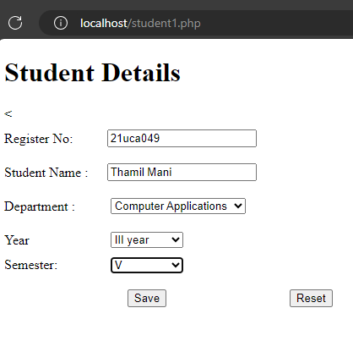

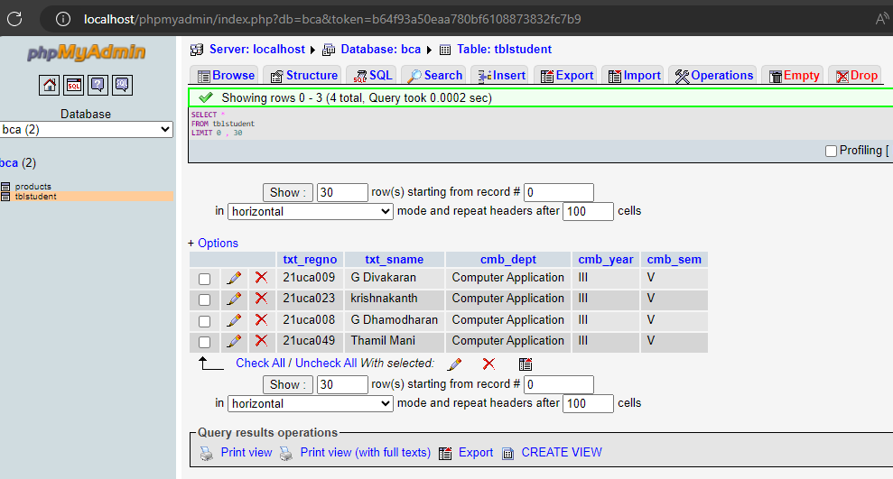

**12.Product Details**

<?php

ob_start();

session_start();

$link=mysqli_connect("localhost", "root", "") or die("Cannot connect mysql software");

mysqli_select_db($link, "bca") or die("cannot select 15bca database");

if(isset($_REQUEST["mode"])=="save")

{

    mysqli_query($link, "insert into products values(". $_REQUEST['txt_pid'] .",'". $_REQUEST['txt_pname'] ."','". $_REQUEST["cmb_qtype"] ."','". $_REQUEST["txt_price"] ."')");

    if(mysqli_affected_rows($link))

    {

        $_SESSION["msg"]="Saved Successfully";

    }

    header("location:product.php");

}

if(isset($_REQUEST["mode"])=="")

{

?>

<html>

    <head>

        <title>Product Master</title>

        <script language="javascript">

            function valid()

            {

                var a=0;

                if(!a.test(document.frm.txt_pid.value))

                {

                    alert("Enter the Product Id Properly...");

                    document.frm.txt_pid.value="";document.frm.txt_pid.focus();

                    return false;

                }

            }

        </script>

    </head>

    <body>

        <h3>PRODUCT DETAILS</h3>

        <form name="frm" method="post" action="product.php?mode=save" onSubmit="return valid();">

        <table border="0" cellpadding="0" cellspacing="0" width="300">

            <tr height="40">

                <td>Product Id *</td>

                <td>:&nbsp;<input type="text" name="txt_pid" value=""></td>

            </tr>

            <tr height="40">

                <td>Product Name</td>

                <td>:&nbsp;<input type="text" name="txt_pname" value=""></td>

            </tr>

            <tr height="40">

                <td>Qty Type</td>

                <td>:&nbsp;<select name="cmb_qtype">

                    <option value="1">--Select--</option>

                    <option value="Kgs">Kgs</option>

                    <option value="Lts">Lts</option>

                    <option value="Nos">Nos</option>

                    </select>

                </td>

            </tr>

            <tr height="40">

                <td>Price</td>

                <td>:&nbsp;<input type="text" name="txt_price" value=""></td>

            </tr>

            <tr height="60">

                <td colspan="2" align="center">

                    <input type="submit" value="Save">&nbsp;&nbsp;<input type="reset" value="Reset">

                </td>

            </tr>

        </table>

<?php

if(isset($_SESSION["msg"])!="")

{

    echo $_SESSION["msg"];

    $_SESSION["msg"]="";

}

?>

</body>

</html>

<?php

}

?>

